RAWLINS INTERAGENCY DISPATCH CENTER
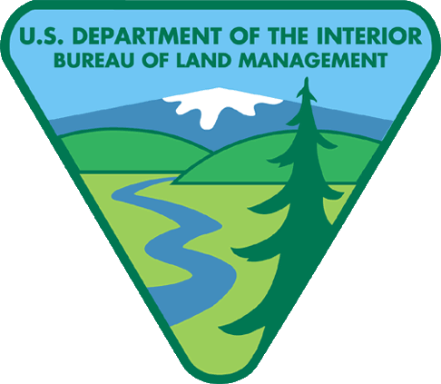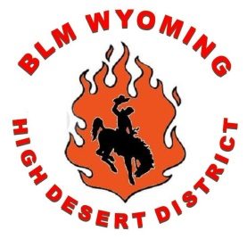
2016 ANNUAL REPORT

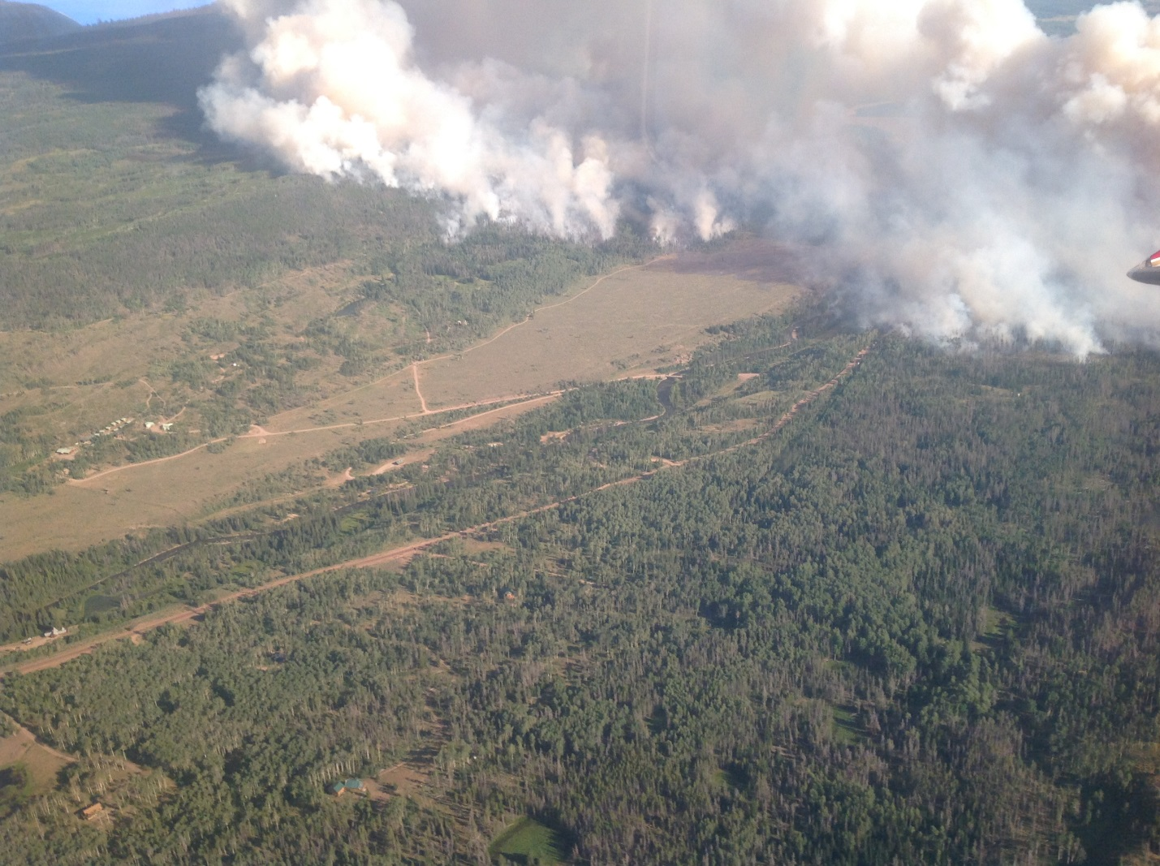
Figure 1 Tokewanna

Introduction to the Center
Rawlins Interagency Dispatch Center (RWC) is hosted by Bureau of Land Management’s High Desert District. RWC provides services for nine counties (ALX-Albany, CAX-Carbon, FAX-Fremont, LAX-Laramie, LIX-Lincoln, PAX-Platte, SUX-Sublette, SWX-Sweetwater, and UIX-Uinta), four BLM Field Offices (Rawlins, Rock Springs, Kemmerer, and Pinedale), BLM Wyoming State Office, Wyoming State Forestry, the National Park Service (Grand Teton), and the US Fish & Wildlife Service. At the time of this report there is strong movement to combine Casper (CPC) with Rawlins Dispatch, in Capser.

Our staff includes one Center Manager, one Assistant Center Manager, one permanent full time Initial Attack Dispatcher, and one career-seasonal Logistics Dispatcher. During the summer months we hire one to three seasonal dispatchers. 2016 RWC hired three seasonal dispatchers.

The dispatch zone covers approximately 21 million acres in the state of Wyoming. 48% of this land is owned by the Federal Government (approximately 10 million acres). A large percent of the High Desert District is checkerboard due to the Union Pacific Railroad that runs through Southern Wyoming. This type of land ownership is cause for a multiple agency response to incidents throughout the District.

Center Funding
Rawlins Dispatch Center is funded predominantly by the Bureau of Land Management through the High Desert District. This includes facility costs for the center as well as labor costs associated with staffing the center. All personnel are BLM funded employees, assigned to the High Desert District’s Fire Management program.

Center Activity 2016
On August 23, 2015, the Center Manager position was filled with Tina Flodeen. She has since retired so the CM position is once again vacant with no plans of filling the position due to the upcoming merger with Casper Dispatch.

Staffing for the winter of 2016 included, Center Manager Tina Flodeen, Acting Center Manager/Assistant Center Manager Gary Batchelder, Lead Dispatcher Brad Weller and Logistics Dispatcher Wendy Finnegan along with 3 seasonals.

Fire Activity
RWC saw a below average fire season with a total of 95 fires, (both human and natural starts) for a total of 2697ac. Our 8 year average is 9089ac. Summer of 2012 saw total acreage of 51464 so that pushes the average high. The average excluding 2012 is 3035 making 2016 closer to the norm. The surrounding center had above average centers so a majority of the summer was spent in support of those centers.
Noteworthy fires:
Tokewanna – Type 2 fire, Team Black assigned, human start, total of 1275ac, 355 on BLM 923 on private.
Book Out – Type 3 fire local T3 team assigned, natural start, total of 82ac, 35 on BLM 47 on private.

Fires by Unit

Total Acreage of Human and Natural Starts

Weather
In 2015 RWC saw 45 Red Flag Warning Days and 20 Fire Weather Watches. The first Red Flag Warning was issued Febuary 26th for south eastern Wyoming or zone 310. The last Red Flag Warning was issued on November 16th for south eastern Wyoming in the Laramie area or zone 309. 2016 was a realitivly dry year with a average of 3.68” of moisture from the 5 RAWS stations.

WILDCAD INCIDENTS BY TYPE

INCIDENT TYPE | NUMBER
Aircraft | 20
Medical Aid | 6
Miscellaneous | 72
Prescribed Fire | 9
Resource Order | 109
SAR | 0
Smoke Check | 57
Structure Fire | 1
Vehicle Fire | 5
Wildfire | 88
Red flag/fire wx watches | 65
Total | 432

Given the nature of a moderately slow fire season on HDD, Rawlins Dispatch was able to fill multiple resource orders in support of our neighbors and to the southern area.

Priority Training
The Priority Training program put together by Kim Bang, the Region 2 Training Specialist, was a great success for HDD. RWC sent out 7 overhead on trainee assignments with 4 completing their taskbook and getting signed off.

Aviation
BLM Contracted Type 3 Standard Helicopter
N32HX began its 90 day contract on June 12th and ended its season on September, including a 9 day extension. It was staffed with a module of 7 personnel. During its 99 days of contract the helicopter flew 144.2 total hours of which 19.7 of those hours were firefighting operations within the RWC zone. It delivered a total of 64,507 gl of water, 44,595 lbs of cargo (both internal and externally) and transported 431 passengers.
Rawlins SEAT Base
In support of the 2016 fire season the Rawlins SEAT base was open for approximately 135 days. During the season, Rawlins SEAT base supported a total of 3 helicopters, 3 Single Engine Air Tankers, and 1 Smokejumper aircraft. Rawlins SEAT base delivered 14,695 gallons of retardant at a cost of $44,085 via 20 sorties at a cost of $104,125 in support of five fires.

